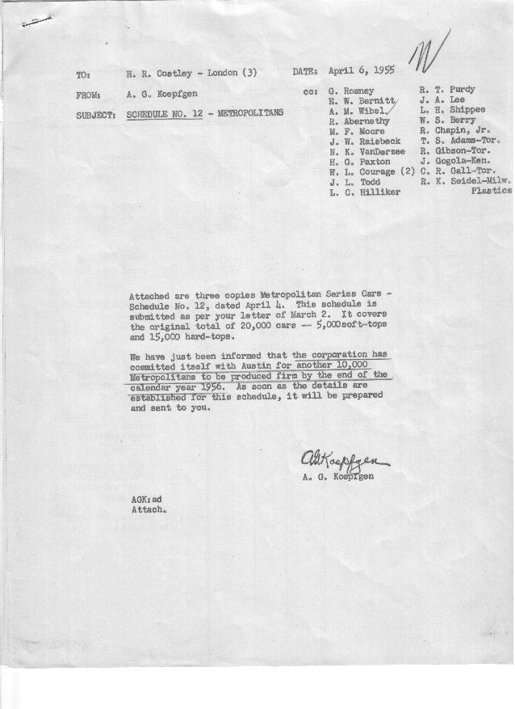

FORM PLAN 68 REV. 2-55-A.M.P APPROVED J. W. Raisbeck (signed) DATE 4-5-55

SCHEDULE NO. ______12________ DATE April 4, 1955 MONTHLY BUILDING SCHEDULE APPROVED W. L Courage (signed)_ DATE_ 4-5-55 ____ REVISION NO. ______ _______ DATE __ PRODUCT APPROVED_____E. W. Bernitt (signed) ___________DATE_ 4-5-55 ____
METROPOLITAN SERIES CARS – AUSTIN MOTORS C. LTD., ENGLAND
DESCRIPTION | BUILT  ◻ACT EST  THRU  Feb., 1955 | FIRM BUILDING SCHEDULE  (FABRICATED MATERIAL RELEASE) |  |  |  |  |  |  |  |  |  |  |  |  |  |  | TENTATIVE SCHEDULE  (RAW MATERIAL RELEASED) |  |  | GRAND  TOTAL
DESCRIPTION | BUILT  ◻ACT EST  THRU  Feb., 1955 | MONTH March  DAYS 23 |  |  | MONTH April  DAYS 18 |  |  | MONTH May  DAYS 20 |  |  | MONTH June  DAYS 22 |  |  | MONTH July  DAYS 16 |  |  |  |  |  | GRAND  TOTAL
DESCRIPTION | BUILT  ◻ACT EST  THRU  Feb., 1955 | DAILY | MONTH | CUM’L  TOTAL | DAILY | MONTH | CUM’L  TOTAL | DAILY | MONTH | CUM’L  TOTAL | DAILY | MONTH | CUM’L  TOTAL | DAILY | MONTH | CUM’L  TOTAL | DAILY | MONTH | TOTAL | GRAND  TOTAL
NASH
Hard-Top Conv. | 8123 |  | 386 | 8509 |  | 295 | 8804 |  | 342 | 9146 |  | 491 | 9637 |  | 397 | 10034
Soft-Top Conv. | 3923 |  | 189 | 4112 |  | 150 | 4262 |  | 168 | 4430 |  | 37 | 4467 |  | 0 | 4467
Total | 12046 |  | 575 | 12621 |  | 445 | 13066 |  | 510 | 13576 |  | 528 | 14104 |  | 397 | 14501
HUDSON
Hard-Top Conv. | 2991 |  | 166 | 3157 |  | 137 | 3294 |  | 138 | 3432 |  | 235 | 3667 |  | 163 | 3830
Soft-Top Conv. | 362 |  | 64 | 426 |  | 48 | 474 |  | 52 | 526 |  | 7 | 533 |  | 0 | 533
Total | 3353 |  | 230 | 3583 |  | 185 | 3768 |  | 190 | 3958 |  | 242 | 4200 |  | 163 | 4363
CORPORATION TOTAL
Hard-Top Conv. | 11114 | 24 | 552 | 11666 | 24 | 432 | 12098 | 24 | 480 | 12578 | 24-4D  35-18D | 726 | 13304 | 35 | 560 | 13864
Soft-Top Conv. | 4285 | 11 | 253 | 4538 | 11 | 198 | 4736 | 11 | 220 | 4956 | 11-4D | 44 | 5000 | 0 | 0 | 5000
Grand Total | 15399 | 35 | 805 | 16204 | 35 | 630 | 16834 | 35 | 700 | 17534 | 35 | 770 | 18304 | 35 | 560 | 18864
Over/(Under) Sched. #11 | (209) | (10) | (345) | (554) | (15) | (270) | (824) | (15) | (300) | (1124) | (15) | (63) | (1454) | (15) | 318 | (1136)
Revision No. 1
 |  | Month: | August |  | Month: | September
 |  | Days: | 18 |  | Days: | 14.5
NASH
Hard-Top Conv. |  |  | 458 | 10492 |  | 341 | 10833
Soft-Top Conv. |  |  | 0 | 4467 |  | 0 | 4467
Total |  |  | 458 | 14959 |  | 341 | 15300
HUDSON
Hard-Top Conv. |  |  | 172 | 4002 |  | 165 | 4167
Soft-Top Conv. |  |  | 0 | 533 |  | 0 | 533
Total |  |  | 172 | 4535 |  | 165 | 4700
CORPORATION TOTAL
Hard-Top Conv. |  | 35 | 630 | 14494 | 35 | 506 | 15000
Soft-Top Conv. |  | 0 | 0 | 5000 | 0 | 0 | 5000
Grand Total |  | 35 | 630 | 19494 | 35 | 506 | 20000
Over/(Under) Sched. #11 |  | 35 | 630 | (506) | 35 | 506 | 0
Revision No. 1

